**Table of Contents**

1. Process Model 2

1.1 Requirement Specification 2

1.1.1 Functional Requirements 2

1.1.2 Non-Functional Requirements 2

2. Database Design Schema 2

NoSQL ERD (Entity-Relationship Diagram) 2

3. Project Phases 3

Phase 1: Setup and Initial Development (Week 1) 3

Phase 2: Core Features Development (Week 2) 3

Phase 3: Advanced Features (Week 3) 3

Phase 4: Finalization and Testing (Week 4) 3

4. Conclusion 3

# 1. Process Model

## 1.1 Requirement Specification

### 1.1.1 Functional Requirements

* **User Authentication:** Implement secure user login and registration using Firebase Auth.
* **Product Management:** Allow users to browse, add, or remove items from their cart, and enable providers to manage their product listings.
* **Payment Integration:** Provide secure payment options with support for multiple payment methods.
* **Wishlist**: Enable users to save items for future purchases.
* **Order History:** Allow users to view their past orders and reorder from previous purchases.

### 1.1.2 Non-Functional Requirements

* **Scalability:** Design the app to scale easily as user demand increases.
* **Usability:** The app should be intuitive and user-friendly, with minimal learning curve for users.

# 2. Database Design Schema

## NoSQL ERD (Entity-Relationship Diagram)

The BiteBuddy app will utilize a NoSQL database (e.g., Firebase Firestore) that is flexible and scalable. The schema will include the following entities:

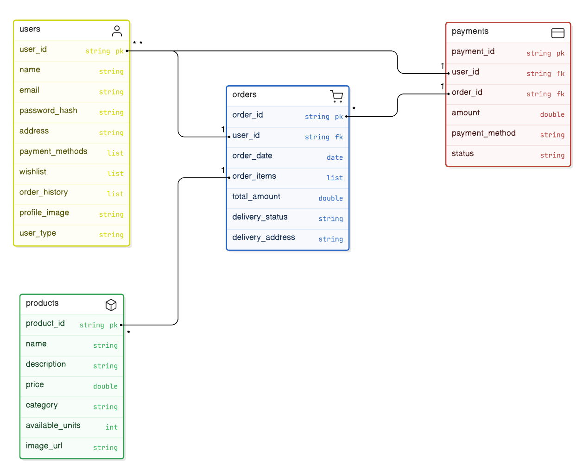

# 3. Project Phases

## Phase 1: Setup and Initial Development (Week 1)

* Set up the development environment.
* Integrate Firebase for authentication and Firestore for database management.
* Develop the basic structure of the app, including user authentication and initial UI components.

## Phase 2: Core Features Development (Week 2)

* Implement core functionalities such as product management, search, and cart management.
* Search functionality with filters.

## Phase 3: Advanced Features (Week 3)

* Develop and integrate advanced features like payment methods, wishlist, and order history.
* Implement user profile management and settings.

## Phase 4: Finalization and Testing (Week 4)

* Perform comprehensive testing, including functional, performance, and security testing.
* Fix any identified bugs and optimize the app for deployment.

# 4. Conclusion

The BiteBuddy app is designed to provide a seamless and user-friendly experience for both customers and food providers. By following a structured process model with clearly defined requirements, database design, and development phases, the project ensures that the app will meet its objectives efficiently and effectively. The Waterfall approach ensures a predictable outcome, delivering a reliable, secure, and scalable solution ready for deployment and user adoption.